***Assignment – 15***

**Using Subqueries with DML Commands.**

1) Assume there is a table called Multicust, with all of the same column definitions as Salespeople. Write a command that inserts all salespeople with more than one customer into this table. 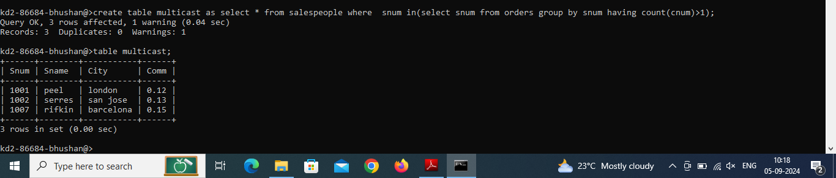

2) Write a command that deletes all customers with no current orders. 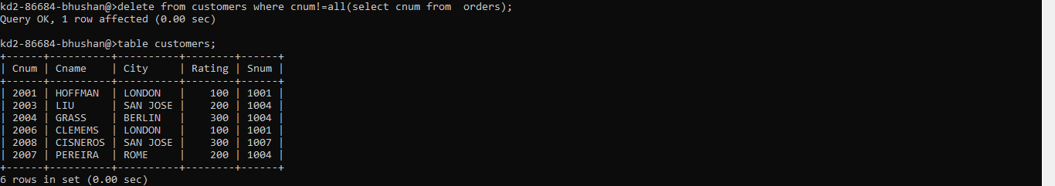

3) Write a command that increases by twenty percent the commissions of all salespeople with total orders above Rs. 3,000. 